The Church of The Apostles is located at:
3585 Northside Parkway, NW
Atlanta, GA 30327
Driving Directions
The church is located north of the intersection of Northside Parkway and West Paces Ferry Road. When traveling north on Interstate 75, exit at West Paces Ferry Road, exit #255. Turn left onto Northside Parkway and the church is approximately one-half mile on the right. When traveling south on Interstate 75, exit West Paces Ferry Road, turn left, then immediately turn left onto Northside Parkway. The church is approximately one quarter of a mile on the right.
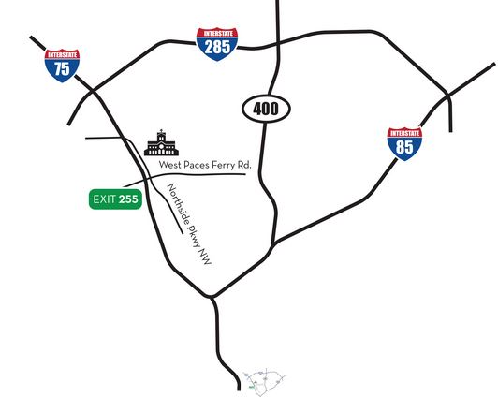
When you enter the Church’s Driveway from Northside Parkway, turn left in front of the parking garage. There is an entrance to parking garage on the right, just as you reach the covered walkway from the garage to the building. Park anywhere in the garage, and then enter through the double doors at the end of the covered walkway.

